Лабораторна робота №3 - звіт

- PR, який не може бути злитий в основну гілку, бо не пройшли автоматизовані тести/аналіз

Test: intentional typo in db query #25
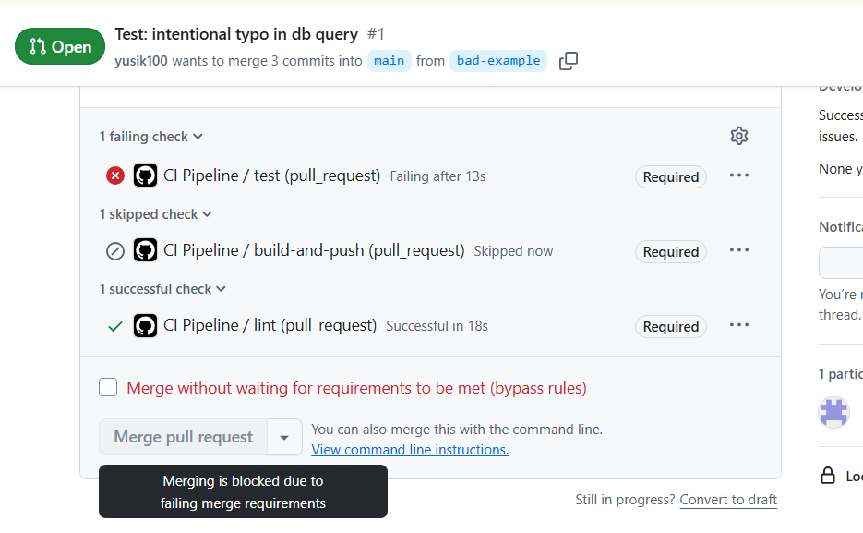

Причина: const [rows] = await pool.kwery("SELECT id, name FROM items");

Run npm test

> mywebapp@1.0.0 test
> jest --coverage
FAIL ./mywebapp.test.js

Simple Inventory API Tests
Health Endpoints
✓ GET /health/alive повинен повертати 200 OK (25 ms)
✓ GET /health/ready повинен повертати 200 OK при доступній БД (8 ms)
✓ GET /health/ready повинен повертати 500 при помилці БД (3 ms)
Main & Items Endpoints
✓ GET / повинен повертати HTML (3 ms)
✕ GET /items повинен повертати список у форматі JSON (4 ms)
✕ POST /items повинен успішно створювати новий предмет (13 ms)
✕ GET /items/:id повинен повертати конкретний предмет (3 ms)

● Simple Inventory API Tests › Main & Items Endpoints › GET /items повинен повертати список у форматі JSON

expect(received).toEqual(expected) // deep equality

Expected: 200
Received: 500

45 |
46 | const res = await request(app).get('/items').set('Accept', 'application/json');
> 47 | expect(res.statusCode).toEqual(200);
| ^
48 | expect(res.body).toEqual(mockItems);
49 | });
50 |

at Object.toEqual (mywebapp.test.js:47:30)

● Simple Inventory API Tests › Main & Items Endpoints › POST /items повинен успішно створювати новий предмет

expect(received).toEqual(expected) // deep equality

- Expected - 1
+ Received + 0

Object {
- "id": 3,
"name": "Шафа",
"quantity": 5,
}

58 |
59 | expect(res.statusCode).toEqual(201);
> 60 | expect(res.body).toEqual({ id: 3, name: 'Шафа', quantity: 5 });
| ^
61 | });
62 |
63 | it('GET /items/:id повинен повертати конкретний предмет', async () => {

at Object.toEqual (mywebapp.test.js:60:24)

● Simple Inventory API Tests › Main & Items Endpoints › GET /items/:id повинен повертати конкретний предмет

expect(received).toEqual(expected) // deep equality

Expected: {"created_at": "2023-01-01", "id": 1, "name": "Стілець", "quantity": 10}
Received: ""

67 | const res = await request(app).get('/items/1').set('Accept', 'application/json');
68 | expect(res.statusCode).toEqual(200);
> 69 | expect(res.body).toEqual(mockItem);
| ^
70 | });
71 | });
72 | });

at Object.toEqual (mywebapp.test.js:69:24)

-------------|---------|----------|---------|---------|--------------------------------------
File | % Stmts | % Branch | % Funcs | % Lines | Uncovered Line #s
-------------|---------|----------|---------|---------|--------------------------------------
All files | 60 | 35.71 | 66.66 | 60 |
mywebapp.js | 60 | 35.71 | 66.66 | 60 | 27,44-54,65,76-85,99,106-121,126-132
-------------|---------|----------|---------|---------|--------------------------------------
Test Suites: 1 failed, 1 total
Tests: 3 failed, 4 passed, 7 total
Snapshots: 0 total
Time: 0.619 s
Ran all test suites.
Error: Process completed with exit code 1.

- PR, який був успішно злитий в основну гілку після проходження усіх перевірок
Після виправлення минулої помилки:
Test: intentional typo in db query #26
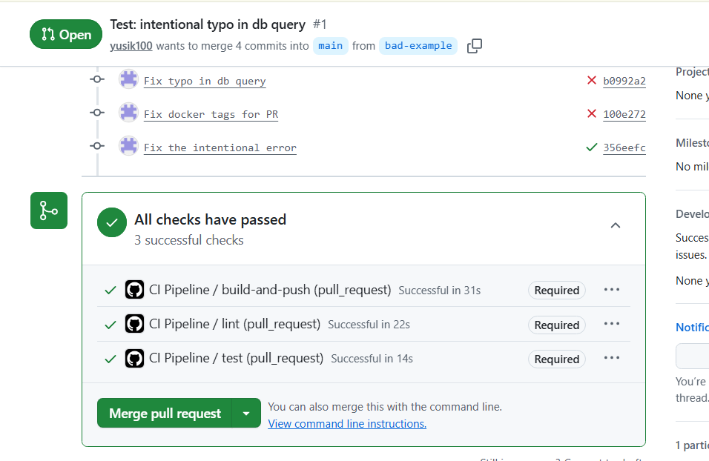
Run npm test

> mywebapp@1.0.0 test
> jest --coverage
PASS ./mywebapp.test.js

Simple Inventory API Tests
Health Endpoints
✓ GET /health/alive повинен повертати 200 OK (25 ms)
✓ GET /health/ready повинен повертати 200 OK при доступній БД (8 ms)
✓ GET /health/ready повинен повертати 500 при помилці БД (3 ms)
Main & Items Endpoints
✓ GET / повинен повертати HTML (3 ms)
✓ GET /items повинен повертати список у форматі JSON (4 ms)
✓ POST /items повинен успішно створювати новий предмет (10 ms)
✓ GET /items/:id повинен повертати конкретний предмет (2 ms)

-------------|---------|----------|---------|---------|--------------------------------------
File | % Stmts | % Branch | % Funcs | % Lines | Uncovered Line #s
-------------|---------|----------|---------|---------|--------------------------------------
All files | 61.53 | 39.28 | 66.66 | 61.53 |
mywebapp.js | 61.53 | 39.28 | 66.66 | 61.53 | 27,46-57,65,76-85,99,106-121,126-132
-------------|---------|----------|---------|---------|--------------------------------------
Test Suites: 1 passed, 1 total
Tests: 7 passed, 7 total
Snapshots: 0 total
Time: 0.598 s
Ran all test suites.

- Лог успішного розгортання проєкту і неуспішної верифікації розгортання

Fix start script to use mywebapp.js #8
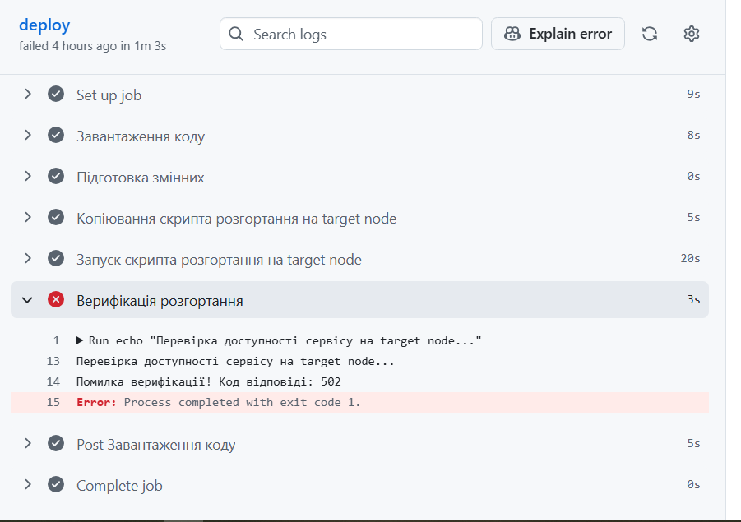
Логи:
Current runner version: '2.334.0'
Runner name: 'runner'
Runner group name: 'Default'
Machine name: 'runner'
GITHUB_TOKEN Permissions
Secret source: Actions
Prepare workflow directory
Prepare all required actions
Getting action download info
Download action repository 'actions/checkout@v4' (SHA:34e114876b0b11c390a56381ad16ebd13914f8d5)
Complete job name: deploy
8s
Run actions/checkout@v4
Syncing repository: yusik100/2-course-trpz
Getting Git version info
Temporarily overriding HOME='/home/student/actions-runner/_work/_temp/72e8d94e-8afa-4e60-9665-7de38f2b3af5' before making global git config changes
Adding repository directory to the temporary git global config as a safe directory
/usr/bin/git config --global --add safe.directory /home/student/actions-runner/_work/2-course-trpz/2-course-trpz
/usr/bin/git config --local --get remote.origin.url
https://github.com/yusik100/2-course-trpz
Removing previously created refs, to avoid conflicts
/usr/bin/git submodule status
Cleaning the repository
Disabling automatic garbage collection
Setting up auth
Fetching the repository
Determining the checkout info
/usr/bin/git sparse-checkout disable
/usr/bin/git config --local --unset-all extensions.worktreeConfig
Checking out the ref
/usr/bin/git log -1 --format=%H
6a7b18306e4f20931db1804fa2bd9cb371a3e248
0s
Run echo "IMAGE_NAME=ghcr.io/yusik100/2-course-trpz/mywebapp:stable" >> $GITHUB_ENV
5s
Run scp -P 2223 -o StrictHostKeyChecking=no lab1/deploy.sh vboxuser@192.168.0.100:/tmp/deploy.sh
20s
Run ssh -p 2223 -o StrictHostKeyChecking=no vboxuser@192.168.0.100 "/tmp/deploy.sh ghcr.io/yusik100/2-course-trpz/mywebapp:stable"
Починаємо розгортання образу: ghcr.io/yusik100/2-course-trpz/mywebapp:stable
Hit:1 http://security.debian.org/debian-security bookworm-security InRelease
Hit:2 http://deb.debian.org/debian bookworm InRelease
Hit:3 http://deb.debian.org/debian bookworm-updates InRelease
Reading package lists...
Reading package lists...
Building dependency tree...
Reading state information...
docker.io is already the newest version (20.10.24+dfsg1-1+deb12u1+b6).
nginx is already the newest version (1.22.1-9+deb12u7).
curl is already the newest version (7.88.1-10+deb12u14).
0 upgraded, 0 newly installed, 0 to remove and 155 not upgraded.
[Unit]
Description=My Web App Docker Container
Requires=docker.service
After=docker.service

[Service]
Restart=always
ExecStartPre=-/usr/bin/docker rm -f mywebapp-container
ExecStartPre=/usr/bin/docker pull ghcr.io/yusik100/2-course-trpz/mywebapp:stable
ExecStart=/usr/bin/docker run --name mywebapp-container -p 3000:8000 ghcr.io/yusik100/2-course-trpz/mywebapp:stable
ExecStop=/usr/bin/docker stop mywebapp-container

[Install]
WantedBy=multi-user.target
server {
listen 80;
server_name _;

location / {
proxy_pass http://127.0.0.1:3000;
proxy_set_header Host $host;
proxy_set_header X-Real-IP $remote_addr;
}
}
Розгортання успішно завершено
3s
Run echo "Перевірка доступності сервісу на target node..."
Перевірка доступності сервісу на target node...
Помилка верифікації! Код відповіді: 502
Error: Process completed with exit code 1.
5s
Post job cleanup.
/usr/bin/git version
git version 2.43.0
Temporarily overriding HOME='/home/student/actions-runner/_work/_temp/14ac3f69-3c05-48a7-945b-30a92382d08d' before making global git config changes
Adding repository directory to the temporary git global config as a safe directory
/usr/bin/git config --global --add safe.directory /home/student/actions-runner/_work/2-course-trpz/2-course-trpz
/usr/bin/git config --local --name-only --get-regexp core\.sshCommand
/usr/bin/git submodule foreach --recursive sh -c "git config --local --name-only --get-regexp 'core\.sshCommand' && git config --local --unset-all 'core.sshCommand' || :"
/usr/bin/git config --local --name-only --get-regexp http\.https\:\/\/github\.com\/\.extraheader
http.https://github.com/.extraheader
/usr/bin/git config --local --unset-all http.https://github.com/.extraheader
/usr/bin/git submodule foreach --recursive sh -c "git config --local --name-only --get-regexp 'http\.https\:\/\/github\.com\/\.extraheader' && git config --local --unset-all 'http.https://github.com/.extraheader' || :"
/usr/bin/git config --local --name-only --get-regexp ^includeIf\.gitdir:
/usr/bin/git submodule foreach --recursive git config --local --show-origin --name-only --get-regexp remote.origin.url
0s
Cleaning up orphan processes
Warning: Node.js 20 actions are deprecated. The following actions are running on Node.js 20 and may not work as expected: actions/checkout@v4. Actions will be forced to run with Node.js 24 by default starting June 2nd, 2026. Node.js 20 will be removed from the runner on September 16th, 2026. Please check if updated versions of these actions are available that support Node.js 24. To opt into Node.js 24 now, set the FORCE_JAVASCRIPT_ACTIONS_TO_NODE24=true environment variable on the runner or in your workflow file. Once Node.js 24 becomes the default, you can temporarily opt out by setting ACTIONS_ALLOW_USE_UNSECURE_NODE_VERSION=true. For more information see: https://github.blog/changelog/2025-09-19-deprecation-of-node-20-on-github-actions-runners/

- Лог успішного розгортання проєкту і успішної верифікації розгортання

Add retry logic to verification step #9

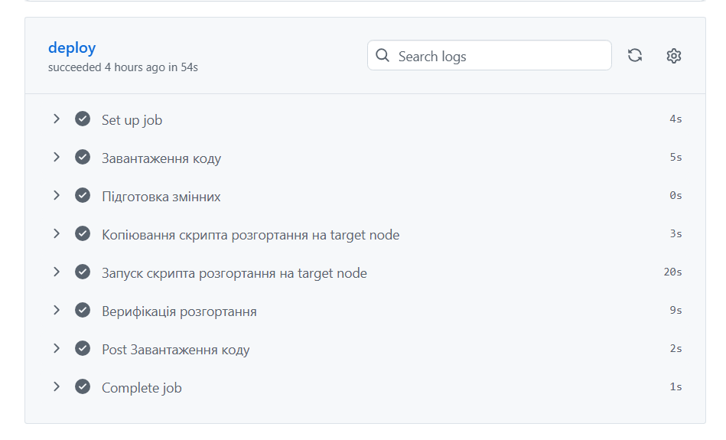
Логи:
Current runner version: '2.334.0'
Runner name: 'runner'
Runner group name: 'Default'
Machine name: 'runner'
GITHUB_TOKEN Permissions
Secret source: Actions
Prepare workflow directory
Prepare all required actions
Getting action download info
Download action repository 'actions/checkout@v4' (SHA:34e114876b0b11c390a56381ad16ebd13914f8d5)
Complete job name: deploy
5s
Run actions/checkout@v4
Syncing repository: yusik100/2-course-trpz
Getting Git version info
Temporarily overriding HOME='/home/student/actions-runner/_work/_temp/bf9f0954-7d45-4a8d-8430-d0b7a4bff6e4' before making global git config changes
Adding repository directory to the temporary git global config as a safe directory
/usr/bin/git config --global --add safe.directory /home/student/actions-runner/_work/2-course-trpz/2-course-trpz
/usr/bin/git config --local --get remote.origin.url
https://github.com/yusik100/2-course-trpz
Removing previously created refs, to avoid conflicts
/usr/bin/git submodule status
Cleaning the repository
Disabling automatic garbage collection
Setting up auth
Fetching the repository
Determining the checkout info
/usr/bin/git sparse-checkout disable
/usr/bin/git config --local --unset-all extensions.worktreeConfig
Checking out the ref
/usr/bin/git log -1 --format=%H
b8105d989d28ed553d8baaf889fc6af391b51cb9
0s
Run echo "IMAGE_NAME=ghcr.io/yusik100/2-course-trpz/mywebapp:stable" >> $GITHUB_ENV
3s
Run scp -P 2223 -o StrictHostKeyChecking=no lab1/deploy.sh vboxuser@192.168.0.100:/tmp/deploy.sh
20s
Run ssh -p 2223 -o StrictHostKeyChecking=no vboxuser@192.168.0.100 "/tmp/deploy.sh ghcr.io/yusik100/2-course-trpz/mywebapp:stable"
Починаємо розгортання образу: ghcr.io/yusik100/2-course-trpz/mywebapp:stable
Hit:1 http://security.debian.org/debian-security bookworm-security InRelease
Hit:2 http://deb.debian.org/debian bookworm InRelease
Hit:3 http://deb.debian.org/debian bookworm-updates InRelease
Reading package lists...
Reading package lists...
Building dependency tree...
Reading state information...
docker.io is already the newest version (20.10.24+dfsg1-1+deb12u1+b6).
nginx is already the newest version (1.22.1-9+deb12u7).
curl is already the newest version (7.88.1-10+deb12u14).
0 upgraded, 0 newly installed, 0 to remove and 155 not upgraded.
[Unit]
Description=My Web App Docker Container
Requires=docker.service
After=docker.service

[Service]
Restart=always
ExecStartPre=-/usr/bin/docker rm -f mywebapp-container
ExecStartPre=/usr/bin/docker pull ghcr.io/yusik100/2-course-trpz/mywebapp:stable
ExecStart=/usr/bin/docker run --name mywebapp-container -p 3000:8000 ghcr.io/yusik100/2-course-trpz/mywebapp:stable
ExecStop=/usr/bin/docker stop mywebapp-container

[Install]
WantedBy=multi-user.target
server {
listen 80;
server_name _;

location / {
proxy_pass http://127.0.0.1:3000;
proxy_set_header Host $host;
proxy_set_header X-Real-IP $remote_addr;
}
}
Розгортання успішно завершено
9s
Run echo "Перевірка доступності сервісу на target node..."
Перевірка доступності сервісу на target node...
Поки що код 502. Додаток запускається, чекаємо 5 секунд...
Верифікація успішна! Код відповіді: 200
2s
Post job cleanup.
/usr/bin/git version
git version 2.43.0
Temporarily overriding HOME='/home/student/actions-runner/_work/_temp/d99c88fc-36a8-4c48-bb4e-08914dc2a769' before making global git config changes
Adding repository directory to the temporary git global config as a safe directory
/usr/bin/git config --global --add safe.directory /home/student/actions-runner/_work/2-course-trpz/2-course-trpz
/usr/bin/git config --local --name-only --get-regexp core\.sshCommand
/usr/bin/git submodule foreach --recursive sh -c "git config --local --name-only --get-regexp 'core\.sshCommand' && git config --local --unset-all 'core.sshCommand' || :"
/usr/bin/git config --local --name-only --get-regexp http\.https\:\/\/github\.com\/\.extraheader
http.https://github.com/.extraheader
/usr/bin/git config --local --unset-all http.https://github.com/.extraheader
/usr/bin/git submodule foreach --recursive sh -c "git config --local --name-only --get-regexp 'http\.https\:\/\/github\.com\/\.extraheader' && git config --local --unset-all 'http.https://github.com/.extraheader' || :"
/usr/bin/git config --local --name-only --get-regexp ^includeIf\.gitdir:
/usr/bin/git submodule foreach --recursive git config --local --show-origin --name-only --get-regexp remote.origin.url
1s
Cleaning up orphan processes
Warning: Node.js 20 actions are deprecated. The following actions are running on Node.js 20 and may not work as expected: actions/checkout@v4. Actions will be forced to run with Node.js 24 by default starting June 2nd, 2026. Node.js 20 will be removed from the runner on September 16th, 2026. Please check if updated versions of these actions are available that support Node.js 24. To opt into Node.js 24 now, set the FORCE_JAVASCRIPT_ACTIONS_TO_NODE24=true environment variable on the runner or in your workflow file. Once Node.js 24 becomes the default, you can temporarily opt out by setting ACTIONS_ALLOW_USE_UNSECURE_NODE_VERSION=true. For more information see: https://github.blog/changelog/2025-09-19-deprecation-of-node-20-on-github-actions-runners/

- Звіт по покриттю коду тестами
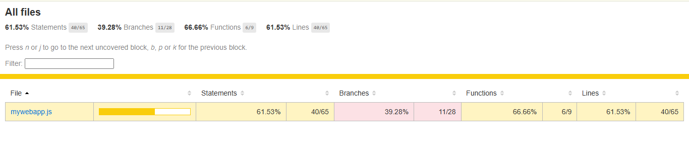
Add retry logic to verification step #21

